n8n (AI-Powered Workflow Automation Tool)
Shoaib Bin Habib | 2312448042

Introduction
n8n (pronounced "n-eight-n") is a powerful, open-source workflow automation platform that enables individuals and organizations to connect applications, automate repetitive tasks, and build complex AI-powered pipelines — all without needing advanced programming skills. The name stands for "nodemation," reflecting its node-based visual interface where each step in a workflow is represented as a node.
Unlike traditional automation tools that are purely cloud-based, n8n can be self-hosted, giving users full control over their data and infrastructure. It also offers a cloud-hosted version for convenience. With over 400+ native integrations — including Google Workspace, Slack, GitHub, OpenAI, WhatsApp, and many more — n8n makes it easy to automate virtually any business or personal workflow.
What sets n8n apart from competitors like Zapier or Make (formerly Integromat) is its flexibility and AI capabilities. Users can incorporate Large Language Models (LLMs) such as GPT or Claude directly into their workflows, enabling intelligent automation that goes beyond simple trigger-action logic. From sending scheduled messages to processing data with AI, n8n is a comprehensive automation ecosystem.

Prompt
In n8n, a "prompt" refers to how you instruct the system and the AI model within your workflow. Unlike traditional text-based AI tools where you type a single prompt in a chat box, n8n's prompting is node-based and context-driven.
Primary Input Methods:
- Trigger Nodes: Define when a workflow starts (e.g., Schedule Trigger, Webhook, Gmail Trigger).
- AI Message Node: You write a natural language prompt inside the "Message a Model" node to instruct the AI (e.g., OpenAI or Claude) on what to generate or analyze.
- Dynamic Expressions: Use n8n's expression syntax ({{ }}) to inject dynamic data — such as today's date or a user's name — directly into your AI prompt.
- System Prompts: Optionally configure a system-level instruction that shapes the AI model's personality or task scope (e.g., "You are a motivational coach. Every morning, generate a short, uplifting productivity tip.").

Output
For the n8n workflow demonstrated in this assignment, the output is a daily AI-generated motivational and productivity message delivered automatically to a specified WhatsApp number every morning at 8:00 AM.
Workflow Overview:
- Schedule Trigger fires at 8:00 AM every day.
- "Message a Model" node (using OpenAI GPT) generates a unique, uplifting productivity message based on the configured prompt.
- WhatsApp Sender node posts the generated message to a WhatsApp number via a WhatsApp API (e.g., WhatsApp Business API or a third-party provider).
Description of Output:
The output is a short, human-like motivational message — freshly generated by AI each day — that appears directly in the recipient's WhatsApp chat. Because the message is AI-generated dynamically, it is never repetitive and can be tailored to themes like productivity, mindfulness, or goal-setting. This workflow demonstrates how n8n seamlessly bridges scheduling, AI intelligence, and real-world messaging into a single automated pipeline.

Prompt Engineering
To get the best possible output from the AI model inside n8n, consider these five prompt engineering strategies:
1. Define a Clear Role for the AI:
Use the system prompt to assign a specific persona to the model, such as "You are a motivational life coach who sends a short, uplifting daily message." This keeps the AI's tone and output format consistent every day.
2. Inject Dynamic Context with Expressions:
Use n8n's expression syntax to inject the current day or date into your prompt — for example, "Today is {{ $now.format('dddd, MMMM D') }}. Generate a productivity tip relevant to this day of the week." This makes the output feel personalized and timely.
3. Specify Output Format and Length:
WhatsApp messages should be short and readable. Instruct the AI explicitly: "Keep the message under 100 words, use simple language, and end with an emoji." Without this, the model may produce overly long or formal responses unsuitable for messaging.
4. Add Variety Instructions to Avoid Repetition:
Prompt the model to vary its themes: "Rotate between themes such as time management, gratitude, focus, and physical wellness. Never repeat a topic used in recent messages." This prevents the workflow from feeling monotonous over time.
5. Test and Iterate Using n8n's Built-in Executor:
Use the "Execute Workflow" button in n8n to test your workflow before scheduling it. Review the AI's response in the output panel and refine your prompt iteratively — adjusting tone, length, or structure — until the message meets your expectations.

Step-by-Step Setup Guide: WhatsApp Morning Message Workflow

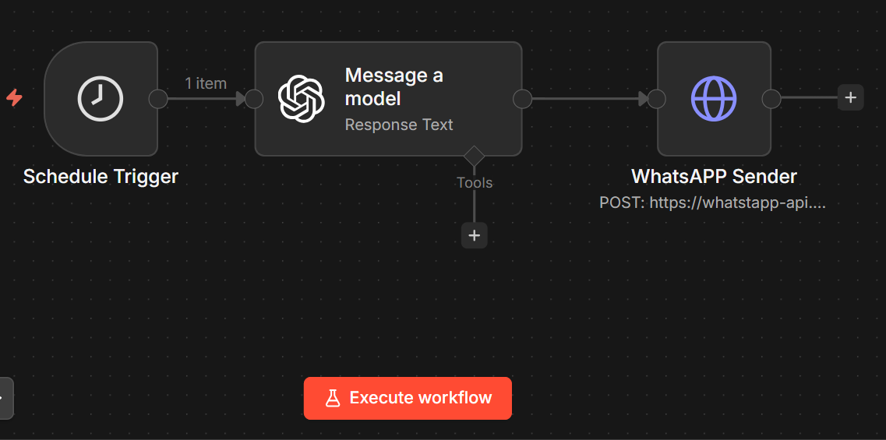
Follow these steps to set up the automated daily WhatsApp productivity message workflow in n8n:

Step 1: Sign Up or Log In to n8n
- Go to https://n8n.io and create a free cloud account, or self-host n8n on your own server.
- Once logged in, click "New Workflow" from the dashboard.

Step 2: Add a Schedule Trigger Node
- Click the "+" button on the canvas to add a new node.
- Search for and select "Schedule Trigger."
- Set the trigger to run Daily at 8:00 AM.
- Make sure your timezone is correctly configured in n8n's settings.

Step 3: Add an AI Model Node ("Message a Model")
- Click "+" and search for "OpenAI" or "Message a Model."
- Connect your OpenAI API key under Credentials.
- Select the model (e.g., gpt-4o or gpt-3.5-turbo).
- In the User Message field, enter your prompt, for example:
"Generate a short, uplifting productivity message for the morning. Keep it under 80 words, friendly in tone, and end with a motivational emoji."
- Connect this node to the Schedule Trigger output.

Step 4: Set Up a WhatsApp API Credential
- You need access to a WhatsApp messaging API. Options include:
- WhatsApp Business API (Meta) — official but requires approval.
- Third-party providers like Twilio, 360dialog, or Wati — easier to set up for testing.
- Obtain your API endpoint URL and authentication token from your chosen provider.
- Store the API key securely in n8n's Credentials section.

Step 5: Add the WhatsApp Sender Node
- Click "+" and add an HTTP Request node (used as the WhatsApp Sender).
- Set the method to POST and paste your WhatsApp API endpoint URL.
- In the request body, map the AI-generated text using the expression:
{{ $json["text"] }} or {{ $node["Message a Model"].json["text"] }}
- Set the recipient's WhatsApp phone number in the appropriate body field.
- Add your API token in the Authorization header (e.g., Bearer YOUR_TOKEN).

Step 6: Test the Workflow
- Click the "Execute Workflow" button at the bottom of the canvas.
- Check each node's output panel to verify the AI response is generated correctly.
- Confirm the WhatsApp node returns a successful 200 OK status.
- Check your WhatsApp — the message should appear within seconds.

Step 7: Activate the Workflow
- Once testing is successful, toggle the workflow to Active using the switch in the top-right corner.
- n8n will now automatically run the workflow every morning at 8:00 AM without any manual intervention.
- You can monitor past executions in the "Executions" log to ensure everything is running smoothly.

Conclusion
n8n is a transformative workflow automation platform that combines the power of AI with hundreds of integrations to make intelligent automation accessible to everyone. The workflow demonstrated in this assignment — a daily AI-generated WhatsApp motivation message — showcases how n8n can orchestrate scheduling, language model inference, and real-world messaging into a seamless, fully automated system.
Compared to traditional automation tools like Zapier, n8n stands out for its open-source flexibility, self-hosting capability, and deep AI integration. For developers and non-developers alike, it provides an intuitive visual interface without sacrificing power or customizability. The ability to embed LLMs directly into workflows opens the door to truly intelligent automation — far beyond simple rule-based triggers.
Whether you are building productivity tools, business pipelines, or personal assistants, n8n empowers you to automate the complex and focus on what matters most.
Note: The AI model used in this workflow is OpenAI GPT (via the "Message a Model" node) for generating daily motivational messages.

